

**CDAGeoV3TM**

**Software Operating Manual**

**Version 0.1**

**Date 18/10/2021**

Add device picture if applicable

Document Changes

|  |  |  |
| --- | --- | --- |
| ***Version*** | ***Date*** | ***Changes*** |
| 0.1 | 18/10/2021 | First Draft |
|  |  |  |
|  |  |  |
|  |  |  |
|  |  |  |
|  |  |  |
|  |  |  |
|  |  |  |
|  |  |  |
|  |  |  |
|  |  |  |
|  |  |  |
|  |  |  |

Table of Contents

1 Introduction 4

2 Starting Screen 4

2.1 Starting the Software 4

2.2 Selecting a Run 5

2.3 Changing Process Duration 6

2.4 Filtering a Run 6

2.5 Identifying Alarms 7

3 Geometry Analysis 8

3.1 Load and Display Geometry Data 8

3.2 Caution and Warning templates. 8

# Introduction

This document provides instructions for the operation of the new CDA (Cable Data Analysis) software.

The primary purpose of the CDA is to analyse data captured by the UltraScreen system, for analysis both during and after the manufacturing process. The software provides a variety of data such as the cable’s layer thicknesses, the cable concentricity, and others.

# Starting Screen

## Starting the Software

Double click the CDAGeoV3 desktop shortcut to start the software. Alternatively, the executable can be located at: “C:/Executables/CDAGeoV3/Release/CDAGeoV3.exe”. The software will take a couple of seconds to launch.

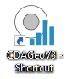

Figure - Desktop Shortcut

Once the software has loaded, the main form will appear.

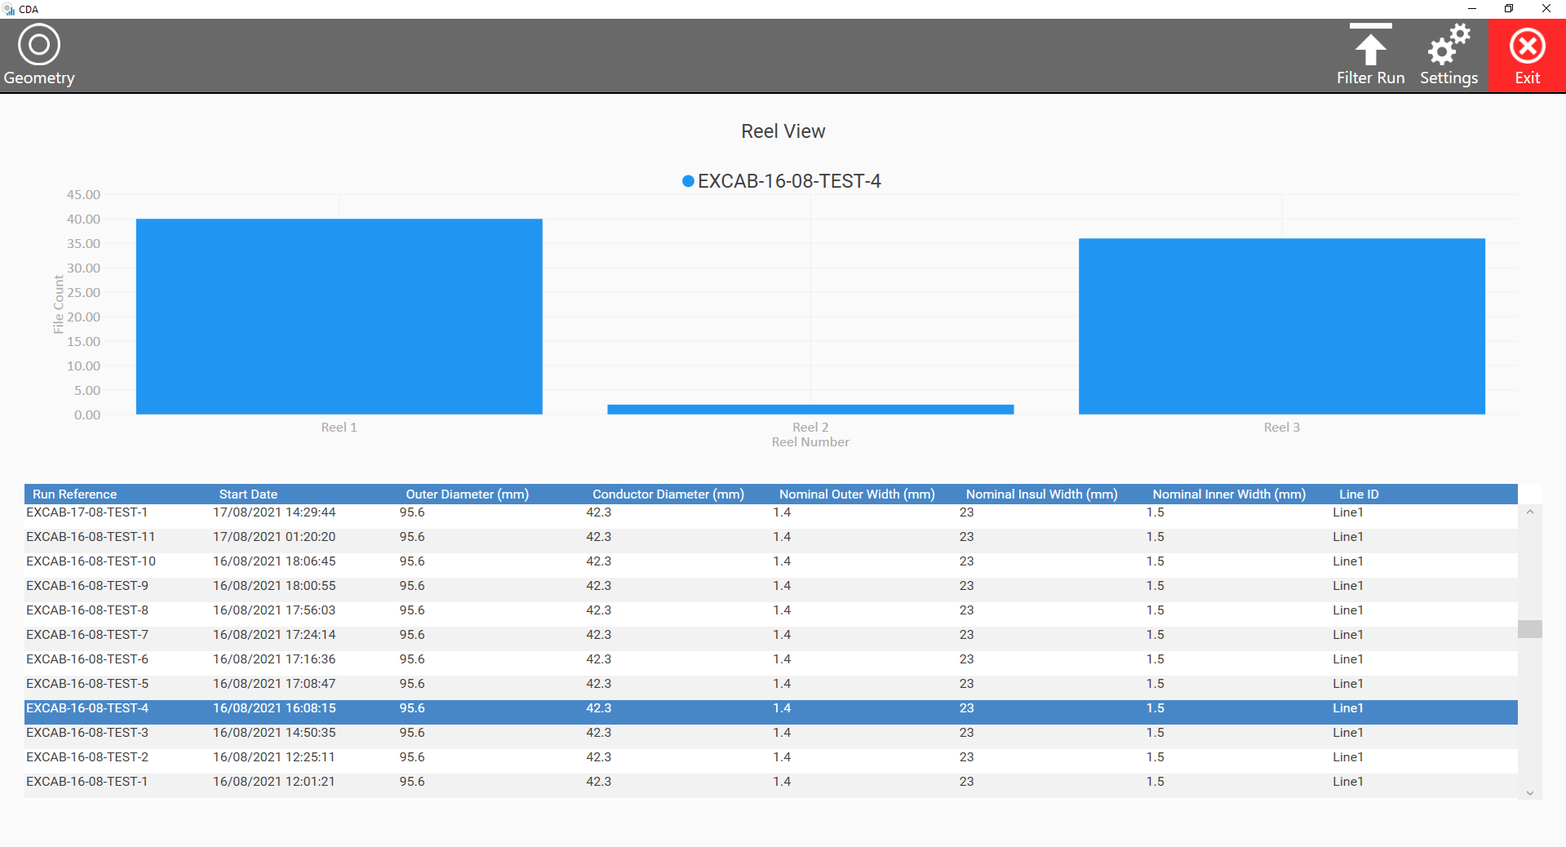

Figure - Reel View

## Selecting a Run

Runs can be analysed by being selected from the runs table. The selected run is highlighted in blue. This is also where a summary of the cable recipe can be found, displaying the nominal layer measurements.

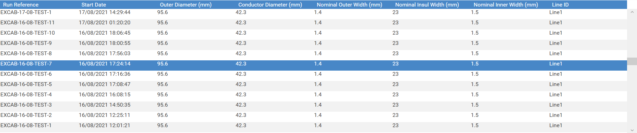

Figure - Select Run Grid

Once selected, the chart is updated with the individual reel data.

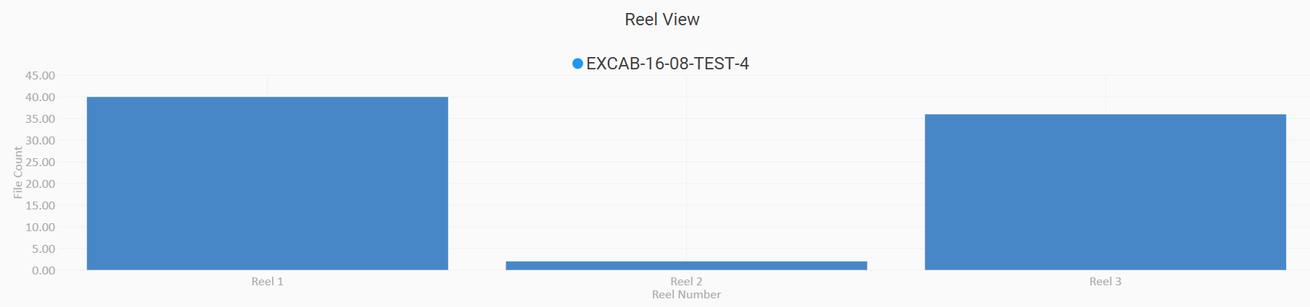

Figure – Reel Data Chart

## Changing Process Duration

To analyse individual reels or the entire run, the process duration can be changed with the ‘Settings’ button located in the top-right hand corner.

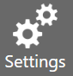

Figure - Settings Button

Upon clicking the Settings button, a pop-up is displayed. Hover over the ‘Process Duration’ text, then click on the appropriate setting.

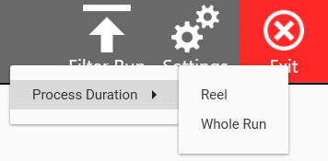

Figure - Changing Process Duration

## Filtering a Run

Filtering a run is a process usually undertaken when an older run is occupying unnecessary space on the local hard drive. Filtering the run will delete the raw and track files, which typically occupy gigabytes.

Note: If necessary, these files can be recreated at a later date by reprocessing the run (contact Acuity).

To filter a run, click the ‘Filter Run’ button at the top-right hand corner.

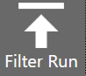

Figure - Filter Run Button

If there are no files to be deleted, a dialog window is displayed.

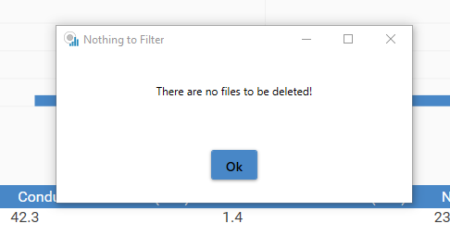

Figure - Nothing to Filter Dialog

Otherwise, a Filter Run dialog window is opened.

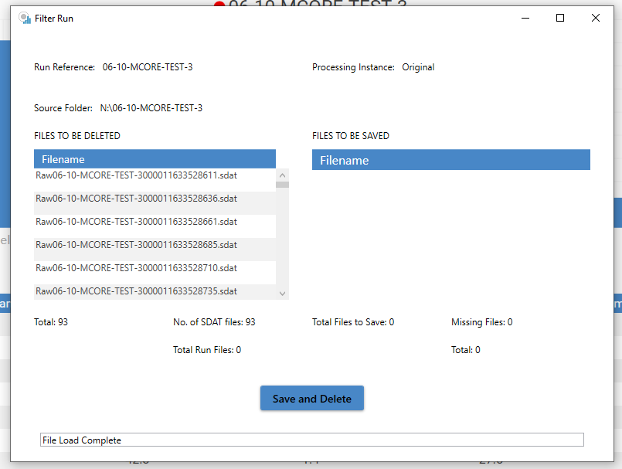

Figure - Filter Run Window

To Filter the run and delete the files, click the ‘Save and Delete’ Button.

## Identifying Alarms

Alarms are present when the reel chart is coloured in red. If no alarms are present in the run, the charts are blue.

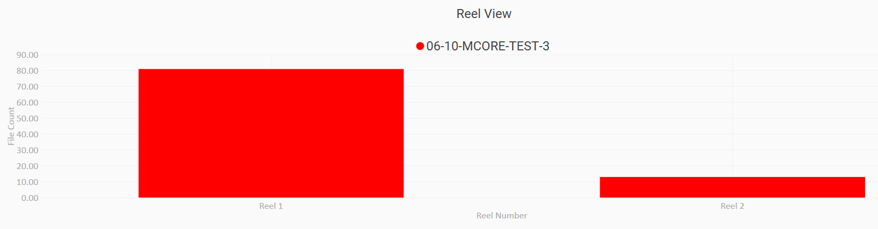

Figure - Chart with alarms

# Geometry Analysis

## Load and Display Geometry Data

To start analysing a run, firstly select a reel by selecting a chart column with the mouse. The selected reel will subsequently turn orange.

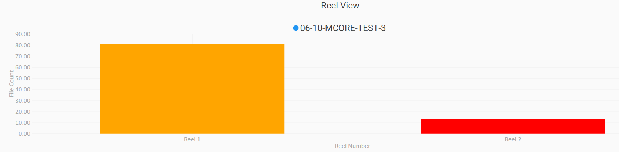

Figure - Chart with Selected Reel

Next, select the ‘Geometry’ button located at the top-left corner.

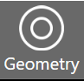

Figure - Geometry Button

Once the geometry data has loaded, the geometry form will appear.

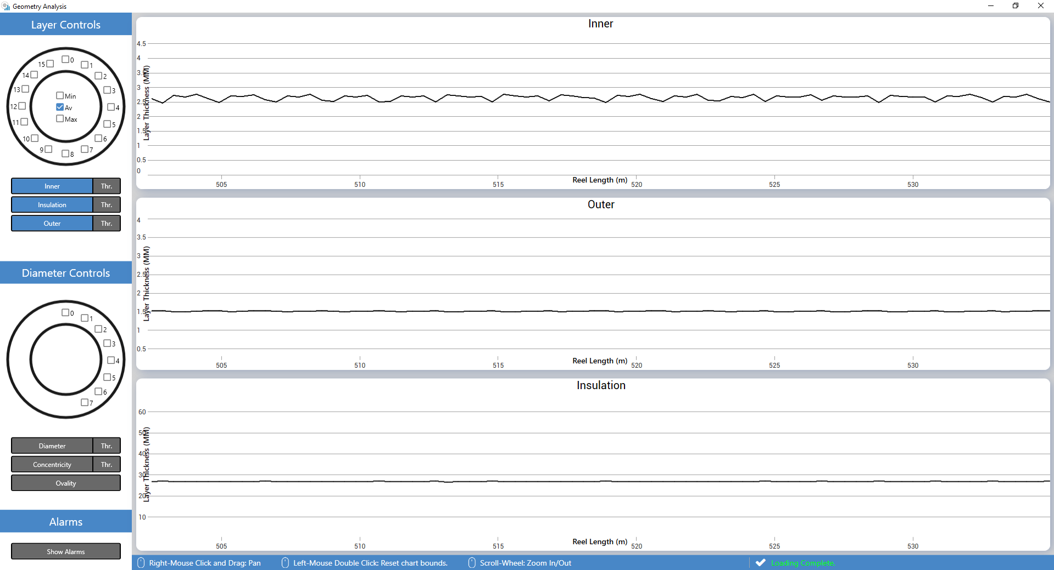

Figure - Geometry View Window

By default, the average value for Outer, Inner, and Insulation layer thicknesses are displayed.

## Layer and Diameter Controls

The contents of the charts are controlled entirely by the sidebar located on the left side of the window.

## Caution and Warning templates.

Caution – Safety information to prevent damage to machinery

|  |  |
| --- | --- |
|  |  |

Warning – Safety information to prevent operator injury or serious damage to the machinery.

|  |  |
| --- | --- |
|  |  |

Caution Example

|  |  |
| --- | --- |
|  | ***Always use the “Send to Load Position” control to send the scanning head to the cable load position. Do not attempt to load the cable with the scanning head in any other position. This could lead to the scanning head being out of alignment for the scan which could result in damage to the machine*** |

Warning Example

|  |  |
| --- | --- |
|  | ***As soon as the “GO” button is pressed the scanning head will begin to move. To prevent injury or damage to the machine, make sure the path of the scanning head is free from obstruction.*** |

Use both caution and warning at the same time if necessary.

